# Email Signature Instructions

1. Create a new email.

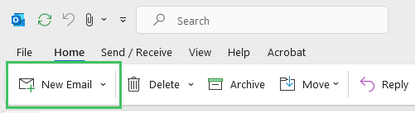

1. At the top of the new message, click the **“Signatures”** option.

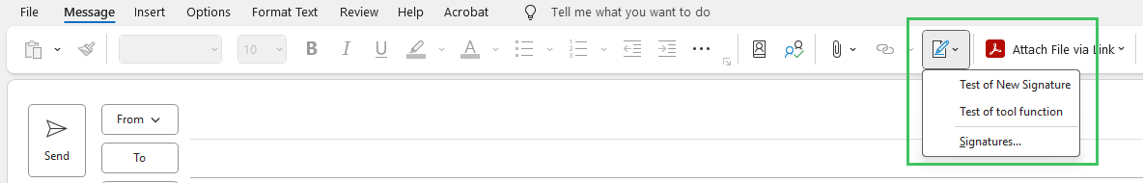

1. 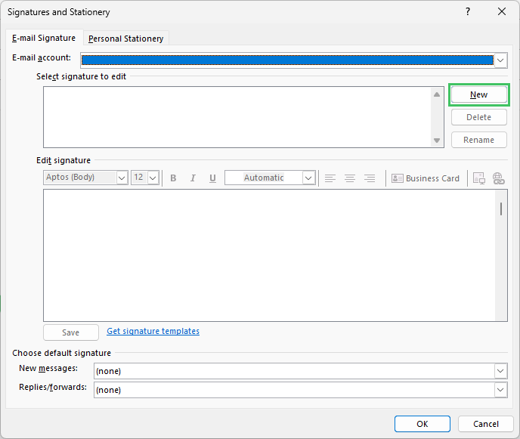The “**Signatures and Stationery**” box should appear. Next, click the “**New**” button.
2. 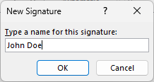This will bring up the “**New Signature**” window. Please enter a name for your new signature and click “**OK**.”
3. In the box under “**Edit Signature**,” paste the Avnet-branded signature that you copied from the web page by navigating to the top “**Edit**” menu in your browser and choosing “**Paste**” or press the Ctrl and V keys together.
4. 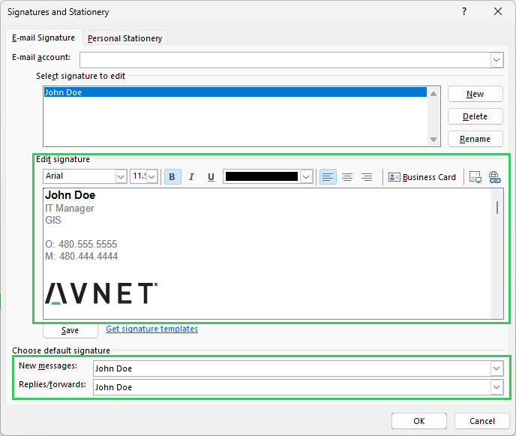Under the “**Choose default signature**” section, select the new signature in the “**New messages**” drop-down and the “**Replies/Forwards**” drop-down menu and then click “**OK**.”
5. Close the email and open a new email to confirm that your new signature appears.

Congratulations! Your new signature will be applied to all emails going forward.